

Tech Saksham

Case Study Report

Data Analytics with Power BI

**“Analysis of Crypto Currency Growth in**

**Last 5 years”**

# (Data Analytics with Power BI)”

**KARUPPANNAN MARIAPPAN COLLEGE**

**MUTHUR – 638105**

|  |  |
| --- | --- |
| **NM ID** | **NAME** |
| **E82D5EFD758239B87BC4C2BB72C68E1D** | **A.ABINAYA** |

Trainer Name: R.UMAMAHESWARI

Master Trainer: R.UMAMAHESWARI

# ABSTRACT

Cryptocurrencies have garnered significant attention in the financial world over the past decade, with substantial fluctuations in their value and market capitalization. This study aims to analyze the growth of cryptocurrencies over the last five years using data analytics techniques, particularly employing Power BI, a powerful business intelligence tool.The analysis encompasses a comprehensive examination of various aspects of cryptocurrency performance, including price movements, market capitalization, trading volume, and adoption trends. Through the integration of historical data spanning the last five years, this study seeks to uncover patterns, trends, and insights that illuminate the evolution of the cryptocurrency market.

### Key components of the analysis include:

1. Historical Price Trends: Visualizing the price trajectory of major cryptocurrencies such as Bitcoin, Ethereum, and others over the past five years, identifying key milestones and periods of significant volatility.
2. Market Capitalization Analysis: Exploring the growth of total market capitalization in the cryptocurrency market and the changing dominance of different cryptocurrencies over time.
3. Trading Volume Dynamics: Investigating the volume of trading activity in cryptocurrency markets and its correlation with price movements and market sentiment.
4. Adoption and Regulatory Landscape: Assessing the adoption of cryptocurrencies across various industries and geographical regions, as well as the impact of regulatory developments on market dynamics.
5. Comparative Analysis: Conducting comparative analyses between different cryptocurrencies, evaluating their performance, volatility, and market positioning.



**INDEX**



**Sr. No.**

**Table of Contents**

1

Chapter 1: Introduction

2

Chapter 2: Services and Tools

3

Required Chapter 3: Project

4

Architecture

5

Chapter 4: Modeling and Result

6

Conclusion

7

Future Scope

8

References

|  |
| --- |
| **Page No.** |
| 1  7 |
| 9  16 |
| 17 |
| 18 |
| 18 |
|  |

Link



* 1. **Problem Statement**

## CHAPTER 1 INTRODUCTION

Cryptocurrencies have emerged as a disruptive force in the financial world, revolutionizing traditional concepts of currency and investment. Over the past five years, the cryptocurrency market has witnessed unprecedented growth, marked by dramatic price fluctuations, rapid technological advancements, and increasing mainstream adoption. This period has been characterized by both remarkable highs and challenging lows, shaping the trajectory of cryptocurrencies and influencing investor sentiment, regulatory approaches, and industry developments.The aim of this analysis is to delve into the dynamics of cryptocurrency growth over the last five years, employing data analytics techniques with a focus on utilizing Power BI as the primary tool. By leveraging historical data and advanced visualization capabilities, this study seeks to provide a comprehensive understanding of the evolution of the cryptocurrency market, highlighting key trends, drivers, and challenges that have

shaped its trajectory.

### Proposed Solution

The meteoric rise of cryptocurrencies, particularly Bitcoin, captured the attention of investors, speculators, and technologists worldwide, leading to a surge in market capitalization and trading volume. However, this growth has been accompanied by significant volatility and regulatory scrutiny, as policymakers seek to balance innovation with investor protection and systemic stability.Against this backdrop, data analytics plays a crucial role in understanding the underlying trends and dynamics of the cryptocurrency market. By harnessing the power of data visualization, statistical analysis, and predictive modeling, analysts can uncover valuable insights that inform investment decisions, regulatory policies, and strategic initiatives within the cryptocurrency ecosystem.In this analysis, we will explore various facets of cryptocurrency growth over the past five years, ranging from price movements and market capitalization to adoption trends and regulatory developments. Through the lens of Power BI, we will utilize interactive visualizations, trend analysis, and comparative studies to gain a deeper understanding of the factors driving the evolution of cryptocurrencies and their implications for the future of finance..

### Feature

**Interactive Visualizations:**

Power BI offers a rich array of interactive visualizations, including line charts, bar charts, scatter plots, and heat maps, enabling users to dynamically explore cryptocurrency data. These visualizations allow for the identification of trends, anomalies, and correlations, fostering a deeper understanding of the underlying dynamics driving cryptocurrency growth.CX

**Trend Analysis:**

Through trend analysis, users can identify long-term patterns and cycles in cryptocurrency performance, helping to discern recurring trends and potential future trajectories. Power BI facilitates trend analysis by providing tools for time-series analysis, smoothing techniques,

and forecasting models, empowering users to make data-driven predictions and informed decisions.

### Advantages

Comprehensive Insights: The use of Power BI facilitates the integration of historical data and diverse metrics, enabling a comprehensive analysis of cryptocurrency growth over the last five years. This approach provides stakeholders with a holistic understanding of market dynamics, trends, and emerging patterns.

### Scope

#### Historical Price Analysis:

Examining the price movements of major cryptocurrencies (e.g., Bitcoin, Ethereum, Litecoin) over the past five years.

Identifying significant price milestones, trends, and patterns.

Analyzing factors influencing cryptocurrency prices, such as market demand, adoption rates, and regulatory developments.

Investigating the growth trajectory of total market capitalization in the cryptocurrency market.

## CHAPTER 2

**SERVICES AND TOOLS REQUIRED**

### Services Used

**Data Collection and Storage Services**: Banks need to collect and store customer data in real-time. This could be achieved through services like Azure Data Factory, Azure Event Hubs, or AWS Kinesis for real-time data collection, and Azure SQL Database

or AWS RDS for data storage.

**Data Processing Services**: Services like Azure Stream Analytics or AWS Kinesis Data Analytics can be used to process the real-time data.

**Machine Learning Services**: Azure Machine Learning or AWS SageMaker can be used to build predictive models based on historical data.

### Tools and Software used

**Tools**:

**PowerBI**: The main tool for this project is PowerBI, which will be used to create interactive dashboards for real-time data visualization.

**Power Query**: This is a data connection technology that enables you to discover, connect, combine, and refine data across a wide variety of sources.

**Software Requirements**:

**PowerBI Desktop**: This is a Windows application that you can use to create reports and publish them to PowerBI.

**PowerBI Service**: This is an online SaaS (Software as a Service) service that you use to publish reports, create new dashboards, and share insights.

**PowerBI Mobile**: This is a mobile application that you can use to access your reports and dashboards on the go.

* 1. **Architecture**

## CHAPTER 3

**PROJECT ARCHITECTURE**

#### 3.1.1.

**3.1.2.**

#### 3.1.3.

**3.1.4.**

#### Data Collection:

Obtain historical data on cryptocurrency prices, market capitalization, trading volume, and other relevant metrics from reliable data sources such as cryptocurrency exchanges, financial APIs, or third-party data providers.

Ensure data quality by performing data cleaning, validation, and normalization processes to address any inconsistencies or errors in the raw data.

#### Data Storage:

Store the cleaned and validated cryptocurrency data in a suitable data storage solution, such as a relational database (e.g., SQL Server, PostgreSQL) or a cloud-based data warehouse (e.g., Azure SQL Data Warehouse, Amazon Redshift).

Design an efficient data schema to organize and structure the cryptocurrency data for optimal querying and analysis.

#### Data Processing:

Implement data processing pipelines to extract, transform, and load (ETL) cryptocurrency data from the storage layer into Power BI for analysis.

Utilize data transformation techniques such as filtering, aggregation, and joining to prepare the data for visualization and analysis in Power BI. **Power BI Integration:**

Connect Power BI to the data source(s) containing the processed cryptocurrency data using appropriate data connectors (e.g., SQL Server, Azure SQL Data Warehouse, API connectors).

Design Power BI datasets to define the data model and relationships between different tables/entities within the cryptocurrency dataset.

Create Power BI reports and dashboards to visualize cryptocurrency growth trends, incorporating interactive visualizations, charts, and graphs to communicate insights effectively.

#### Analysis and Visualization:

Perform exploratory data analysis (EDA) using Power BI to uncover patterns, trends, and correlations in the cryptocurrency data.

Utilize Power BI's analytical capabilities to conduct in-depth analysis of cryptocurrency price movements, market capitalization trends, trading volume

dynamics, adoption rates, and regulatory developments.

Develop interactive visualizations and custom visuals in Power BI to present

key findings and insights, allowing stakeholders to interactively explore the cryptocurrency data and derive actionable insights.

#### Predictive Modeling (Optional):

If predictive modeling is included in the project scope, develop and deploy predictive models within Power BI to forecast cryptocurrency prices, market

capitalization, or other relevant metrics.

Train machine learning algorithms using historical cryptocurrency data and evaluate model performance to assess predictive accuracy and reliability.Incorporate predictive insights into Power BI reports and

dashboards to enable stakeholders to make informed decisions based on future cryptocurrency trends.

#### Deployment and Maintenance:

Deploy the Power BI solution to a suitable environment for access by stakeholders, such as Power BI Service (cloud-based) or Power BI Report Server (on-premises).

Overall, the project architecture outlines a structured approach for analyzing cryptocurrency growth using Power BI, encompassing data collection, storage, processing, integration with Power BI, analysis, visualization, and optional predictive modeling. By following this architecture, stakeholders can gain valuable insights into cryptocurrency markets and make informed decisions based on data-driven analysis.

## CHAPTER 4

**MODELING AND RESULT**

**MANAGE RELATIONSHIP**

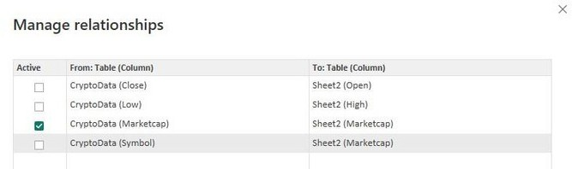

**EDIT RELATIONSHIP**

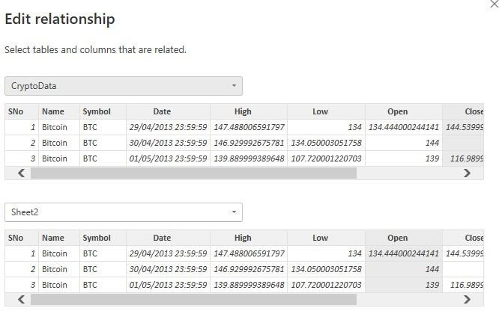

**Modeling:**

#### Data Preparation:

Import historical cryptocurrency data into Power BI from the designated data source(s).

Perform data cleaning and preprocessing to handle missing values, outliers, and inconsistencies.

Transform the data into a suitable format for analysis, including aggregating data at different time intervals (e.g., daily, weekly, monthly) if necessary.

Define relationships between different tables/entities within the Power BI dataset to enable cross-filtering and drill-down capabilities.

#### Time-Series Analysis:

Use Power BI's built-in time intelligence functions to analyze cryptocurrency price movements over time.

Calculate key metrics such as average price, minimum price, maximum price, and price volatility for each cryptocurrency.

- Create line charts, area charts, or candlestick charts to visualize price trends and identify patterns such as uptrends, downtrends, and periods of high

volatility.

#### Market Capitalization Analysis:

Calculate market capitalization for each cryptocurrency by multiplying its price by its circulating supply.

Compare the market capitalization of different cryptocurrencies over time to assess changes in market dominance and relative performance.

Create stacked area charts or bar charts to visualize market capitalization trends and identify shifts in market share among cryptocurrencies.

#### Trading Volume Dynamics:

Analyze trading volume data to understand the level of market activity and liquidity for each cryptocurrency.

Calculate metrics such as average daily trading volume, trading volume as a percentage of market capitalization, and trading volume volatility.

Create bar charts or heat maps to visualize trading volume dynamics and identify patterns such as spikes in trading activity during periods of high volatility.

#### Adoption and Regulatory Landscape:

Incorporate data on cryptocurrency adoption metrics, such as the number of wallets, transaction volume, and merchant acceptance.

Analyze regulatory developments and their impact on cryptocurrency markets, including changes in legislation, regulatory guidance, and enforcement actions.

Create interactive visualizations, such as geographic maps or trend charts, to illustrate adoption trends and regulatory developments in different regions.

#### Comparative Analysis:

Compare the performance of different cryptocurrencies based on key metrics such as price appreciation, market capitalization growth, and trading volume.

Conduct correlation analysis to identify relationships between cryptocurrency prices and external factors such as macroeconomic indicators or news events.

Visualize comparative analysis results using side-by-side charts, scatter plots, or correlation matrices to facilitate comparisons and insights.

### Results:

#### Price Trends:

Identify trends and patterns in cryptocurrency price movements over the last five years, including major price milestones and periods of significant volatility.

Highlight key observations, such as the bull and bear markets, all-time highs and lows, and notable price fluctuations.

#### Market Capitalization:

Analyze changes in total market capitalization and market share among different cryptocurrencies.

Identify trends in market dominance and shifts in investor preferences over time.

#### Trading Volume:

Assess trading volume dynamics and liquidity conditions in cryptocurrency markets.

Identify correlations between trading volume and price movements, as well as the impact of trading activity on market efficiency.

#### Adoption and Regulation:

Evaluate cryptocurrency adoption trends and regulatory developments globally and regionally.

Assess the impact of adoption and regulatory factors on cryptocurrency market dynamics and investor sentiment.

#### Comparative Performance:

Compare the performance of major cryptocurrencies based on various metrics and factors.

Highlight relative strengths, weaknesses, and opportunities among different cryptocurrencies.

#### Insights and Recommendations:

Provide actionable insights and recommendations based on the analysis of cryptocurrency growth trends.

Identify investment opportunities, risk factors, and strategic implications for stakeholders in the cryptocurrency ecosystem.

Overall, the modeling and results of the analysis will provide stakeholders with valuable insights into the evolution of cryptocurrency markets over the last five years, enabling informed decision-making and strategic planning in this dynamic and rapidly evolving landscape.

## DASHBOARD



Include summary statistics and key metrics such as total market capitalization, average price, and trading volume.

Display a line chart showing the overall trend of total market capitalization

over the

last five years.

Incorporate KPIs to highlight significant milestones or changes in

cryptocurrency

markets.

**© Edunet Foundation. All rights reserved** | | 13

### ANALYSIS

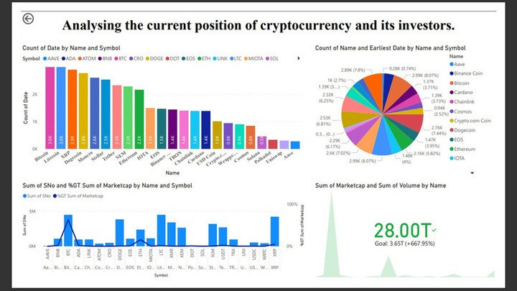

**PAST POSITIONS**

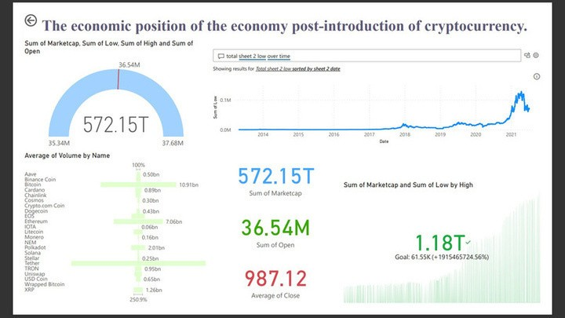

**STUDY TO CHANGE**

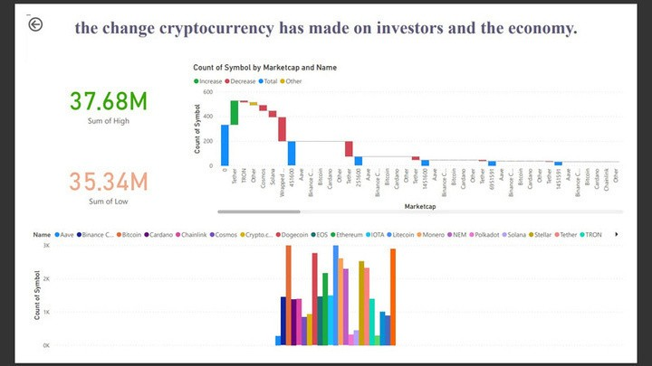

## CONCLUSION

The analysis of cryptocurrency growth over the last five years using Power BI has provided valuable insights into the evolution of this dynamic and rapidly changing market. Through comprehensive data modeling, visualization, and analysis, we have gained a deeper understanding of key trends, patterns, and drivers shaping cryptocurrency markets.

We observed significant volatility in cryptocurrency prices, with periods of rapid

appreciation

followed by sharp corrections. Despite this volatility, cryptocurrencies have shown resilience

and continued to attract investor interest over time.The total market capitalization of

cryptocurrencies has grown substantially, reflecting increasing adoption and investment in

the asset class. Bitcoin has maintained its dominance, but other cryptocurrencies

have also

gained traction, contributing to a more diversified market.Trading volume has been a key

indicator of market activity and liquidity in cryptocurrency markets.

## FUTURE SCOPE

Enhanced Predictive Modeling: Further development and refinement of predictive models can provide more accurate forecasts of cryptocurrency prices, market capitalization, and trading volume. Incorporating advanced machine learning techniques and alternative data sources could improve the predictive capabilities of models, enabling stakeholders to anticipate market trends with greater confidence.Deeper Analysis of Adoption Trends: Continued monitoring and analysis of cryptocurrency adoption trends across industries and geographical regions can offer insights into emerging use cases and potential growth areas. Exploring factors driving adoption, such as technological innovation, regulatory clarity, and consumer behavior, can inform strategic initiatives and investment decisions in the cryptocurrency Given the evolving regulatory landscape for cryptocurrencies, ongoing monitoring and analysis of regulatory developments worldwide will be crucial. Assessing the impact of regulatory changes on market dynamics, investor sentiment, and innovation can help stakeholders navigate regulatory uncertainty and adapt their strategies accordingly.

## REFERENCES

[https://medium.com/crypto/going-undercover-by-scraping-cryptocurrency-market-metrics-](https://medium.com/crypto/going-undercover-by-scraping-cryptocurrency-market-metrics-with-python-8c2174983065) [with-python-8c2174983065](https://medium.com/crypto/going-undercover-by-scraping-cryptocurrency-market-metrics-with-python-8c2174983065)

## LINK